**3 Pcs Islamic Calligraphy Frames, Assalam, Al Aziz, Al Momin Quranic Frames set**

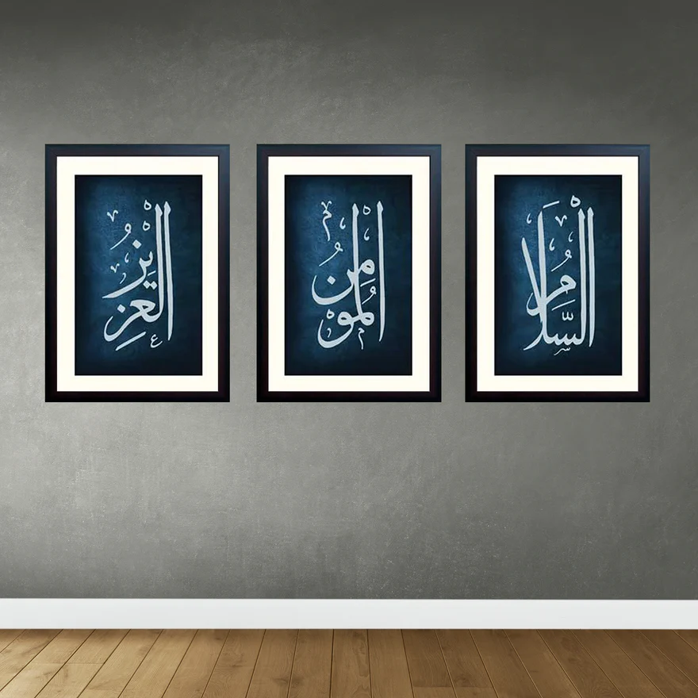The 3 Pcs Islamic Calligraphy Frames Set, featuring "Assalam," "Al Aziz," and "Al Momin" from the Quran, is a striking and spiritually enriching collection of artwork. Each frame showcases the sacred names of Allah in intricate Arabic calligraphy, beautifully designed with elegant borders and fine details. "Assalam" represents peace, "Al Aziz" signifies the Mighty One, and "Al Momin" reflects the Believer, making these frames not only visually appealing but also deeply meaningful. Crafted from high-quality materials, these framed prints are perfect for bringing a sense of tranquillity, reverence, and faith to your living room, prayer room, or any space in your home. This set serves as a beautiful reminder of the divine attributes of Allah, combining both art and spirituality in a harmonious display.